Asumo que en cierto punto del paper se han descrito las variables del dataset. También asumo que la composición de la base de datos es una de las primeras cosas que ya se ha explicado. Por eso, a partir de aquí me referiré a todas las columnas del dataset como variables, independientemente si son indicadores o genes.

1. Data preprocessing

Before conducting the computational study, the dataset was preprocessed as follows:

1- An univariate analysis of outliers is conducted and those values that lie outside 1.5 times the inter-quartile range are removed.

2- All genes with more than 70% of missing values are eliminated.

3- All missing values and outliers are replaced by the median of the variable in each group of patients.

4- All variables with zero variance are removed.

5- All variables are centered by means of subtracting the original values by the mean, and then, they are scaled by means of dividing by the standard deviation. By this way, all variables have the same impact and, therefore, the posterior estimation of the variables’ relevance is not biased by those variables with extreme values.

2. Construction of predictive models with all variables

In this work, we aimed to analyze the effectiveness of the considered variables at predicting diabetes in the population of patients. A logistic regression model is constructed with the SPSS software, and it is also validated with the R language; the aim was to confirm the high AUC values obtained by SPSS. Also, a random forest model was constructed with R, serving as a point of comparison to determine the effectiveness of the aforementioned logistic regression model.

Two scenarios are considered in this work, first the capacity of the model to memorize the data distributions and properties is studied by means of assessing the models with the same data used to construct them (SPSS implements this type of evaluation by default), and second the capacity of generalization of the models is studied by means of assessing the models in a data partition that has not been seen previously. This last scenario is performed in R language by repeating three times a 10-fold cross validation to construct the models, using the same seed to partition the database, so allowing the replication of the computational study. A single 10-fold cross-validation procedure is carried out as follows: (I) the database is partitioned in 10 parts; (II) in each fold execution the model is trained over the union of nine data partitions, and then it is tested on the remaining partition that was not used at training the model; (III) the predictive performance of the model is averaged across all fold executions.

For the first scenario, it can be observed…

As it was expected, the model based on random forest outperforms in XX cases the logistic regression model; this results is normal since ensemble-based methods has shown to be more effective in a wide range of applications [1]. However, it is noteworthy that significant differences are not encountered between the two models when they are compared with the well-known t-test; the null hypothesis is not rejected at the significance level XXX with a p-value equal to XXX.

3. Estimation of the variables’ relevance

So far, the predictive models are constructed by considering all the variables of the database. However, it is well-known that a better predictive performance can be attained if redundant, noisy and interacting variables are removed at the time of constructing models [4, 5]. In this work, several well-known feature weighting algorithms [3] are used to compute the relevance of variables. The variables are ordered from higher to lower relevance according to a weight that represents the ability to distinguish among diabetic and healthy patients. To avoid possible biases in the process of estimating the variables’ relevance, five well-known feature estimation methods are used, namely Correlation-Feature-Selection (CFS) [6], Correlation-Attribute-Evaluation (CAE) [2], Gain-Ratio (GR) [2], Information-Gain (IG) [7], and Relief-F (RF) [8].

These algorithms are filter methods, they evaluate the usefulness of a variable (or a set of variables) through measures of distance, dependency, information or correlation on data [4, 5], so they are not influenced by classification algorithms in the feature estimation process. The use of these supervised feature weighting methods can lead to a superior estimation of the variables’ relevance, having as main advantages: (I) consideration of the expert knowledge unlike of several traditional approaches, such as Principal Component Analysis (PCA) [9], that do not exploit the a priori classification of patients; (II) detection of redundant information; (III) detection of interacting features.

In this work, the five feature weighting methods are assessed by repeating three times a 10-fold cross validation, and the process is implemented in the R language. In the case of RF method, it is executed with a set of number of nearest neighbors equal to {5, 10, 15}. The five estimation methods return ranking of variables and, therefore, an average ranking can be computed as presented in Figure 1. Let us say R_{m} is the ranking of genes computed by the feature weighting method $m$, and $m \in {CFS, CAE, GR, IG, RF}$. $R_m(g)$ represents the rank value of the variable $g$ in the ranking $R_m$, and $G$ is the set of all variables analyzed in the study. The final ranking of genes $R_f$ is equal to:

\begin{equation}
R_f= rank(R_ave)
\end{equation}
, where rank(R_ave) represents a function that ranks the genes according to their average rank values, and $R_ave$ is equal to:
\begin{equation}
R_ave= \underset{\forAll g \in G}{\sum \underset{m \in {CFS,CAE,GR,IG,RF}}{\frac{\sum R_m (g)}{5}}}
\end{equation}

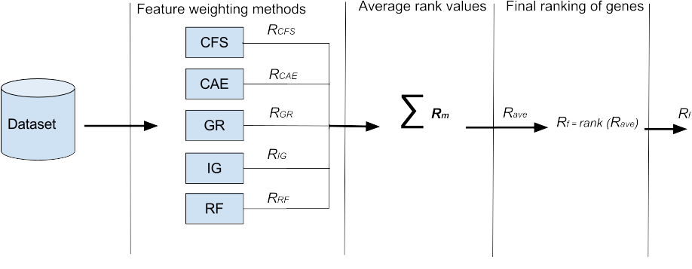

Aquí se pudiera poner algunos resultados para mostrar los ranking generales de las variables.

3.1. Construction of predictive models with subsets of relevant variables

So far, a ranking of variables is computed for each scenario analyzed in this work. However, the direct analysis of a ranking of variables is not an easy task, since it is complex to compute a threshold to decide the point for which all the subsequent variables in the ranking could be considered as irrelevant. In this work, it is also determined the subset of variables that can best predict when a patient develop or not diabetes. To determine the best subset of variables by means of a final ranking of variables, the method proposed by Reyes et al. [5] is extended; it provides an heuristic for searching on feature rankings.

The number of possible subsets of variables is of exponential size $2^n -1$, where $n$ is the number of variables in the dataset. However, the method used only requires evaluating at most $\frac{n(n-1)}{2}$ combination of variables. Given a final ranking $R_f$, let $R_{f}^{g}$ be the sub-ranking of variables, where $g$ is the top variable of the ranking $R_{f}^{g}$; i.e. the sub-ranking of variables is formed by $g$ and all subsequent variables in $R_f$. Figure 2 shows a flowchart with the steps that are performed for each sub-ranking $R_{f}^{g} | \forall g \in R_f$. Finally, the best subset of variables is the one that produces the best classifier at predicting whether a patient has diabetes or not.

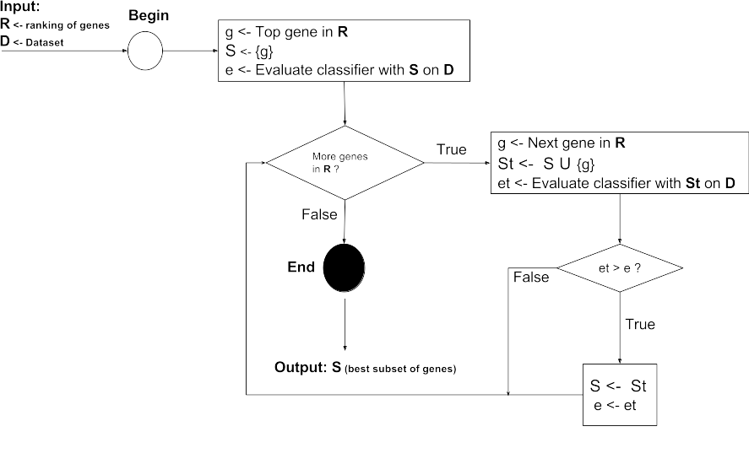

The results show that

References

[1] Leo Breiman. Random Forest. Machine Learning. Vol 45 (1), pp. 5-32, 2001.

[2] S. García, J. Luengo and F. Herrera. Data preprocessing in Data Mining. Springer, vol. 72, 2015.

[3] D. Wettschereck, D.W. Aha and T. Mohri, A review and empirical evaluation of feature weighting methods for a class of lazy learning algorithms. Artificial Intelligence Review, vol. 11, 273–314, 1997.

[4] O. Reyes, C. Morell and S. Ventura. Evolutionary feature weighting to improve the performance of multi-label lazy algorithms. Integrated Computer-Aided Engineering vol. 21, pp. 339–354, 2014.

[5] O. Reyes, C. Morell and S. Ventura. Scalable extensions of the ReliefF algorithm for weighting and selecting features on the multi-label learning context. Neurocomputing, vol. 161, pp. 168–182, 2015.

[6] M. A. Hall. Correlation-based Feature Subset Selection for Machine Learning, PhD. Thesis, The University of Waikato, New Zeland. 1998

[7] Quinlan, J.R.: C4.5: Programs for Machine Learning. Morgan Kaufmann Publishers, 1993.

[8] M. Robnik-Sikonja and I. Kononenko. Theoretical and empirical analysis of ReliefF and RreliefF. Machine Learning, vol. 53 (1–2), pp. 23-69, 2003.

[9] G. Dunteman. Principal Components Analysis. SAGE Publications, Newbury Park , 1989.

